New Release: Timeslips, and User List Search Enhancements
Audience: Suppliers
Release Date: 4/24/18

We are pleased to announce the release of exciting search enhancements!

Timeslip and User List Page Search Enhancements

New functionality has been added to the search filter on the Timeslip and User List pages for HDO and Supplier users.

Timeslip List Page

Previously, the staff members last name was the only name search option on the Timeslip List page. The search results included exact and sound alike matches.

With this release, users can now search by first name in addition to last name. Once a name is keyed into either name field, users can search for only exact name matches by clicking the corresponding exact match checkbox. The First Name and Last Name fields, and corresponding exact match checkbox, can be used together or independently.

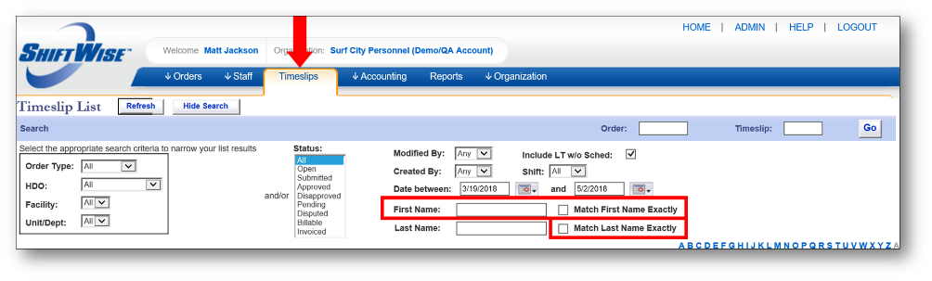
User List Page
Previously, status was the only search option on the User List page.
With this release, users can now search by first name, last name, or email address. Similar to the Timeslip List page, once a name or email is keyed into the name or email field, users can search for exact First Name, Last Name or Email Address exact matches by clicking into the corresponding checkbox. The First Name, Last Name, and Email Address fields (including the corresponding exact match checkbox) can be used together or independently.
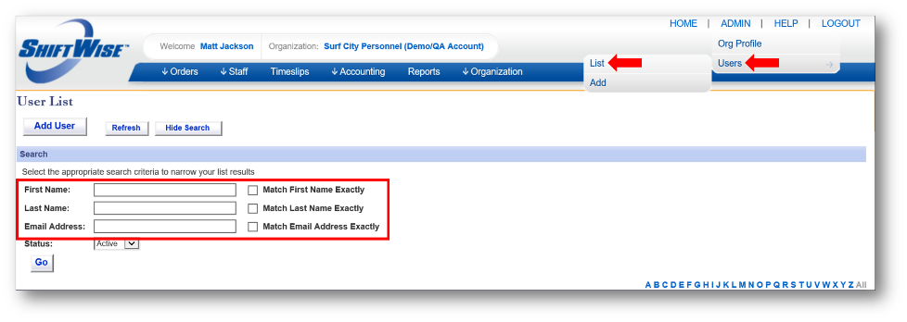

Questions?
Email: support@shiftwise.com
Phone: 866-399-2220

